Lesson 11 - Custom Routing & Web API Part 3

1. Setup your project by following the instructions in **C286 L11 Project Setup.docx**.
2. Open **Task List** window from the menu **VIEW**, **Task List**. Use the **Filter** function in the Project heading to display only the Task for **Lesson11**.
3. **Activity 1:**
   * + 1. Sign up for an Admoren developer account at <https://www.amdoren.com/developer/signup/>.

You can use <https://www.minuteinbox.com/> to get a temporary email just for registration purpose in case the API key is expired and you need to register again.

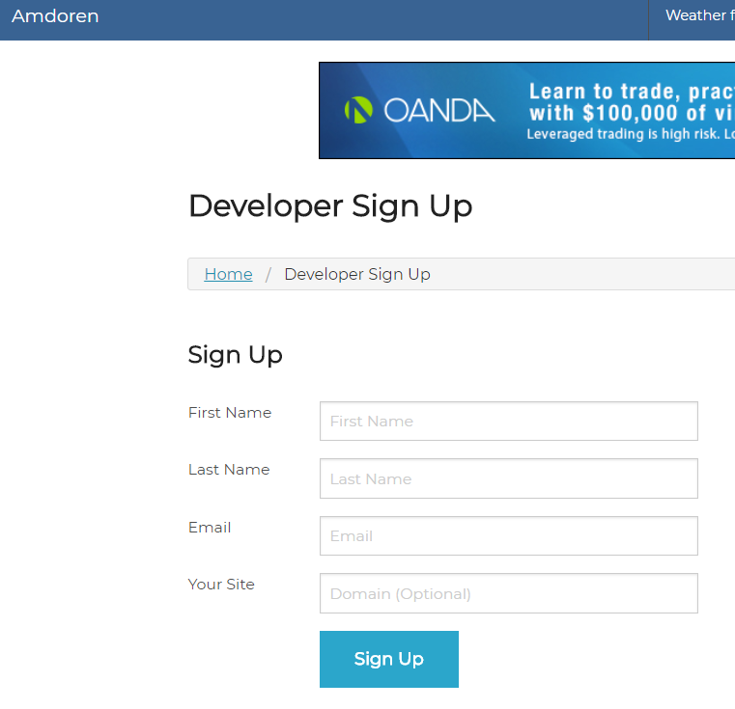

* + - 1. Ensure that you obtained the API Key code:

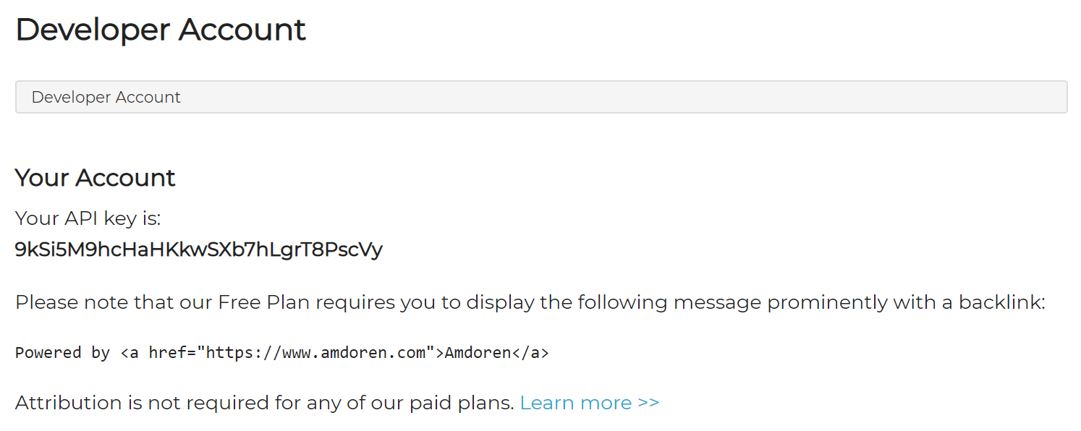

**Your API key will be different from this one**

* + - 1. Make a call to the Amdoren currency exchange web api using browser (Chrome preferred) or Postman to receive exchange rate from SGD to USD using the following information:

Web API address: https://www.amdoren.com/api/currency.php

Parameters:

api_key: **mH48S34y6MVNE7hD9SA2VQtG74MgvN**

from: currency to convert from

to: currency to convert to

1. Write down web API url below:

https://www.amdoren.com/api/currency.php ?api_key=mH48S34y6MVNE7hD9SA2VQtG74MgvN&from=SGD&to=USD

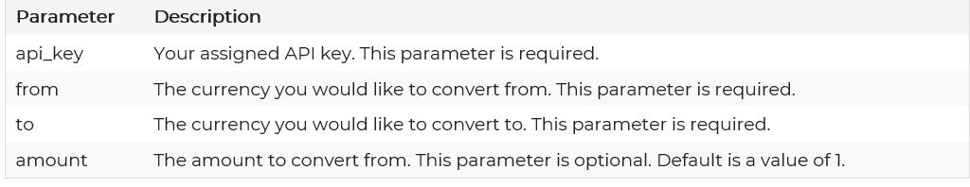

1. Copy and paste the returned result from the web API in the space below

{

    "error": 0,

    "error_message": "-",

    "amount": 0.74369

}

1. Write the anonymous type to represent the returned result below:

new

{

    "error": 0,

    "error_message": "-",

    "amount": 0.74369

}

* + - 1. Call the Amdoren weather web api using browser (Chrome preferred) to receive today and next 4 days weather for Republic Polytechnic:

Web API address: https://www.amdoren.com/api/weather.php

Parameters: https://www.amdoren.com/api/weather.php?api_key={_apiKey}&lat={latitude}&lon={longitude}

api_key: your api key

lat: latitude of the target location

lon: longitude of the target location

1. Write down the web api url below:

**Goto** [**https://www.amdoren.com/latitude-longitude/**](https://www.amdoren.com/latitude-longitude/) **to find out the longitude and latitude of the target location**

Latitude: 1.4428559

Longtitude: 103.7856195

1. Copy and paste the returned result from the web api in the space below

1. Write the anonymous type to represent **weather of the 3rd day** below:

new{

“date” : “2022-01-27”,

“avg_c” : 28,

“min_c” : 22,

“max_c” : 35,

“avg_f” : 82,

“min_f” : 72,

“max_f” : 95,

“summary” : “Partly cloudy”,

“icon” : “wi_color_partly_cloudy_day.png”

}

1. **Activity 2:**
   * + 1. Perform **Tasks 1-1 to 1-5**.
       2. Verify and compare your code with the lecturers’.

1. **Activity 3:**
   1. Examine **Order** controller, fill in the following table based on your analysis of the code witin the class:

|  |  |
| --- | --- |
| Action | Purpose |
| Index | Return string containing all orders detail |
| GetOrder | Return only one order |
| GetOrders | Return multiple orders |
| GetOrdersByDate | Return the orders by date |

* 1. Examine **Product** controller, fill in the following table based on your analysis of the code witin the class:

|  |  |
| --- | --- |
| Action | Purpose |
| Index | Return string containing all products detail |
| GetProduct | Return product |

* 1. Build and run the application, test all actions of **Product**  and **Order** controllers and paste the output into the table for each actions:

|  |  |
| --- | --- |
| Action | Output Image |
| Product/Index |  |
| Product/GetProduct/MO051 |  |
| Order/Index |  |
| Order/GetOrders/01-01-2017 |  |
| Order/GetOrder/0L8013 |  |
| Order/GetOrdersByDate?oyear=2017&omonth=1&&oday=1 |  |

1. **Activity 4:**
   * + 1. Perform **Tasks 2-1 to 2-5**.
       2. Refer to the **Student Notes slides** to help you complete the task.
       3. Test your answers of the exercises using the web request given in the following table and copy and paste the output as well:

|  |  |
| --- | --- |
| Web Request | Output Image |
| Shoppers |  |
| Shoppers/Product |  |
| Shoppers/2017/01/02 |  |
| Shoppers/CZ854 |  |
| Shoppers/2L5481 |  |

* + - 1. Fill in the following table with the corresponding web request in default MVC routing format, {controller}/{action}/{id}:

|  |  |
| --- | --- |
| Web Request | In default MVC routing format |
| Shoppers | Order/Index |
| Shoppers/Product | Product/Index |
| Shoppers/2017/01/02 | Order/GetOrdersByDate?oyear=2017&omonth=01&0day=02 |
| Shoppers/CZ854 | Product/GetProducy/CZ854 |
| Shoppers/2L5481 | Order/GetOrder/2L5481 |

# Solving the Problem

1. You can complete the problem by following the solution tasks in the project. You need to open RPNotes/Index.cshtml to see all solution tasks.
2. Recommended order of implementation:
   1. Custom Routing

* 1. Weather forecast

-Redid the whole thing because the weather forecast wasn’t working either due to timed out api or incorrect implementation in the code.

*— End of Worksheet —*